BUSINESS NEWS PRESS RELEASE

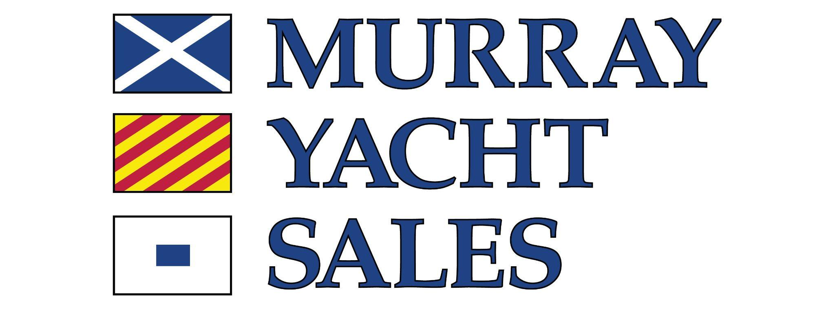
YOUR
LOGO

CONTACT INFORMATION:
Stanton Murray
Murray Yacht Sales
SMurray@MurrayYachtSales.com
+1 800-826-2807

FOR IMMEDIATE RELEASE

Murray Yacht Sales Expands Gulf Coast Team with Addition of Three Brokers in 2026

NEW ORLEANS, LA — September 30, 2026 (12:00 p.m. CT) — Murray Yacht Sales has announced significant expansion of its sales team with the addition of three highly experienced yacht brokers in 2026: David Lee, Tim Todaro, and Wynne Taylor.

This strategic growth reinforces the company’s commitment to providing unparalleled marine expertise, technical knowledge, and premium customer service to boaters across the Gulf Coast.

Dave Lee: Serving the Alabama coastal region, Dave Lee brings over five decades of boating experience to Murray Yacht Sales. An active member of the Pointe Yacht Club in Josephine, Alabama, Lee has extensive personal experience across the spectrum of boating, from competitive yacht club sailing regattas to offshore powerboat cruising and coastal catamaran deliveries. Crucially, Lee leverages his background as a former ASE-certified automotive repair technician to help clients understand the mechanical and design nuances of different vessels. His consultative approach is defined by his unique ability to translate complex technical specifications into practical, real-world advice for his buyers.

Tim Todaro: Operating out of St. Petersburg, Florida, Tim Todaro combines high-level marine credentials with decades of trusted client service. A New Orleans native and Louisiana State University alumnus, Todaro spent 25 years owning and operating a neighborhood wine shop, where building long-term, trust-based relationships was the cornerstone of his success. Today, he is a Licensed and Bonded Florida Yacht Salesman and a proud member of the Yacht Brokers Association of America (YBAA). An avid scuba diver and frequent British Virgin Islands cruiser, Todaro holds a USCG Master License with a Sailing Endorsement, as well as SSI and SDI Scuba Diving Instructor certifications, making him an invaluable resource for clients seeking warmer weather and bluer water.

Wynne Taylor: Serving the Mississippi Gulf Coast boating community, Wynne Taylor turns a lifelong passion for the water into a career of guiding buyers and sellers with transparency and clear communication. A native of the Mississippi coast, Taylor is a highly active one-design and handicap sailboat racer with hundreds of offshore racing miles under his belt. His extensive cruising resume across the Gulf Coast and the Caribbean, coupled with personal ownership of numerous power and sail vessels, equips him with a highly practical understanding of the market. Whether a client is purchasing their first boat or upgrading to a larger yacht, Taylor’s goal is to ensure a smooth, confident transaction from start to finish.

The addition of Lee, Todaro, and Taylor reflects Murray Yacht Sales' ongoing mission to connect buyers and sellers with the most knowledgeable, ethical, and passionate brokers in the Gulf South.

About Murray Yacht Sales
Founded more than 50 years ago, Murray Yacht Sales is a premier yacht brokerage and new-boat dealer serving the Gulf Coast and beyond. With multiple offices across Florida, Louisiana, Mississippi, Alabama, and Texas, the company represents leading brands and offers comprehensive brokerage services for boaters at every stage of ownership.

