BUSINESS NEWS PRESS RELEASE

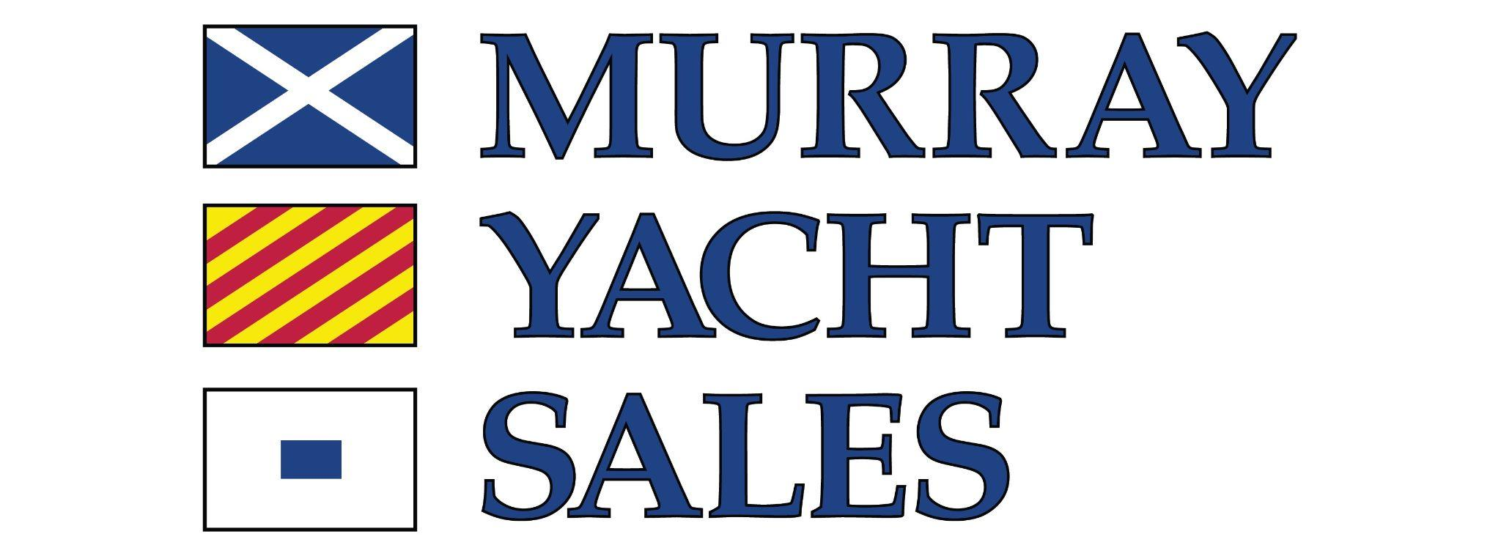
YOUR
LOGO

CONTACT INFORMATION:
Stanton Murray
Murray Yacht Sales
SMurray@MurrayYachtSales.com
+1 800-826-2807

FOR IMMEDIATE RELEASE

Murray Yacht Sales Expands Gulf Coast Team with Addition of Yacht Broker in Corpus Christi

CORPUS CHRISTI, Texas — February 2, 2026 (12:00 p.m. CT) — Murray Yacht Sales has announced the expansion of its Gulf Coast team in Corpus Christi with the addition of William Cox as Yacht Broker, strengthening the company’s presence along the Texas Coast.

The move marks a strategic step in Murray Yacht Sales’ continued regional growth. While the company has historically serviced the Coastal Bend area from its Clear Lake Shores office, the addition of Cox establishes dedicated, on-the-ground representation in Corpus Christi. With offices spanning the Gulf Coast from the West Coast of Florida to South Texas, the expansion further reinforces Murray Yacht Sales’ geographic reach.

Cox brings a lifetime around the water and a deep connection to the Corpus Christi boating community. He holds a U.S. Coast Guard OUPV license and ASA 101-105 sailing certifications, has owned multiple powerboats, regularly crews in local Wednesday night races, and currently cruises aboard his 2007 Jeanneau 39i.

A retired Fire Chief and City Manager, Cox provides a structured, transparent, and seamless brokerage experience for buyers and sellers throughout the Coastal Bend.

The Corpus Christi expansion strengthens Murray Yacht Sales’ Gulf Coast footprint and reflects the firm’s continued investment in regional expertise and personalized client service.

About Murray Yacht Sales
Founded more than 50 years ago, Murray Yacht Sales is a premier yacht brokerage and new-boat dealer serving the Gulf Coast and beyond. With multiple offices across Florida, Louisiana, Mississippi, Alabama, and Texas, the company represents leading brands and offers comprehensive brokerage services for boaters at every stage of ownership.

